**LOVELY PROFESSIONAL UNIVERSITY,**

Phagwara, Punjab



**DEPARTMENT OF COMPUTER SCIENCE**

# PROJECT OF CSE - SEM-4

SYNOPSIS OF THE PROJECT

**SRS DOCUMENT ON E-Commerce Website**

UNDER THE GUIDANCE OF PROJECT CANDIDATES

prof. Ashish Kumar Arjun Arora

12212509

08

# DECLARATION STATEMENT

I hereby declare that the Software Requirements Specification (SRS) document entitled "E-commerce Website" presented at Lovely Professional University, Phagwara, Punjab, is an original work and has not been previously submitted for any other purpose.

I acknowledge that this document adheres to Lovely Professional University’s guidelines on academic integrity, plagiarism, and ethical standards. Hence, I affirm that all the information and analysis contained in this SRS are the result of my own research and effort.

I understand the significance of upholding intellectual property rights and ethical conduct, and I assure that the content of this SRS accurately reflects my genuine endeavour. I take full responsibility for the accuracy and integrity of the information provided in this document.

**Table of Contents**

**REVISION HISTORY........................................................................... ERROR! BOOKMARK NOT DEFINED. CLIENT APPROVAL........................................................................... ERROR! BOOKMARK NOT DEFINED**.

1.INTRODUCTION...............................................................................................................................3 1.1PURPOSE.......................................................................................................................................3

1.2 SCOPE...........................................................................................................................................4

1.3 DEFINITIONS, ACRONYMS, AND ABBREVIATIONS……………………………………..................................4

1.4REFERENCES..................................................................................................................................5 1.5OVERVIEW......................................................................................................................................5

2. GENERAL DESCRIPTION...................................................................................................................6

2.1 PRODUCTPERSPECTIVE.................................................................................................................6

2.2 PRODUCT FUNCTIONS .................................................................................................................7

2.3 USER CHARACTERISTICS ...............................................................................................................7

2.4 GENERAL CONSTRAINTS ...............................................................................................................8

2.5 ASSUMPTIONS AND DEPENDENCIES .............................................................................................8

3. SPECIFIC REQUIREMENTS................................................................................................................ 9

3.1 EXTERNAL INTERFACE REQUIREMENTS .............................................................................................. 9 3.1.1 User Interfaces................................................................................................................................. 9 3.1.2 Hardware Interfaces......................................................................................................................... 9 3.1.3 Software Interfaces.......................................................................................................................... 9 3.1.4 Communications Interfaces............................................................................................................ 10 3.2 FUNCTIONAL REQUIREMENTS........................................................................................................... 10 3.2.1 User Registration Login................................................................................................................... 10 3.2.2 Product Listings............................................................................................................................... 10 3.2.3 Purchasing Cart .............................................................................................................................. 10 3.2.4 Order Processing............................................................................................................................. 11 3.2.5 Payment Processing......................................................................................................................... 12 3.2.6 Customer Management .................................................................................................................. 12 3.2.7 NON-FUNCTIONAL REQUIREMENTS ............................................................................................... 13 3.3.1 Performance.................................................................................................................................... 13 3.3.2 Reliability.......................................................................................................................................... 13 3.3.3 Availability ....................................................................................................................................... 14 3.3.4 Security ........................................................................................................................................... 15 3.3.5 Maintainability ................................................................................................................................ 15 3.3.6 Portability ........................................................................................................................................ 16 3.4 DESIGN CONSTRAINTS ........................................................................................................................ 17 3.5 OTHER REQUIREMENTS ...................................................................................................................... 18 4. ANALYSIS MODELS................................................................................................................................ 18 4.1 DATA FLOW DIAGRAMS (DFD) ............................................................................................................ 18 5.GITHUB LINK……………………………………………………………………………………………………………..……………………….19 6.CLIENT APPROVAL PROOF…………..…………………………………………………….……………………………………………….22 7.A. APPENDICES ...................................................................................................................................... 23 A.1 APPENDIX 1 ........................................................................................................................................ 24

8.CONCLUSION……………………………………………………………………………………………………………………….……………….26

**REVISION HISTORY**

|  |  |  |  |
| --- | --- | --- | --- |
| **Version** | **Date** | **Description** | **Author** |
| 1.0 | 2024-03-24 | Initial Draft | Arjun Arora |
| 1.1 | 2042-04-01 | Added Requirement | Arjun Arora |
| 1.3 | 2024-04-11 | Added Appendices | Arjun Arora |

**CLIENT APPROVAL**

1. INTRODUCTION
   1. PURPOSE

Welcome to our state-of-the-art E-commerce website, where convenience meets efficiency in the delivering the requirements of a daily basis routine. At our E-commerce Service, we have curated an unmatched delivering and product reviewing/viewing experience tailored to fulfill all your lodging requirements. With a user-friendly interface and a robust backend system, our commitment lies in streamlining the entire delivery process, from search to Order , ensuring a seamless journey for our customers.

Whether you're seeking luxury perfumes, cozy outfits , budget-friendly items/products, or anything in between, our extensive database boasts a diverse range of options to suit all customer’s preferences and budgets. Our platform is engineered with a focus on speed, security, and reliability, guaranteeing secure transactions and timely confirmation of your Orders.

Moreover, our dedicated support team stands ready to assist you with any inquiries or assistance needed, providing personalized guidance to enhance your Ordering experience. Join us as we revolutionize the way you order products online, offering not just items but tailored suggestions to make your living experiences memorable. Welcome to the future of E-commerce. Welcome to our E-commerce ordering-Delivering system.

* 1. SCOPE

The aim of the project is to develop a comprehensive online platform for Ordering and delivering of product, facilitating seamless booking experiences for Customers and efficient management for retailers. The system will offer a user-friendly interface, extensive features for ordering,selling,delivering of the items ,secure transaction processing, and robust management functionalities. Key characteristics include:

1.2.1 User-Friendly Interface:

The platform will feature an intuitive interface for Ordering,Selling process, ensuring a pleasant experience for customers.

1.2.2 Extensive Product Listings:

A wide range of Product varieties for a single product, including gifting, Gift cards, and amenities, will be listed to cater to various customers preferences and requirements.

1.2.3 Safe Transaction Processing:

Secure payment gateways will be integrated to facilitate safe and reliable transactions for guests.

1.2.4 Effective Order Management:

Catalog

**PROJECT OF CSE - SEM-4 1**

**DECLARATION STATEMENT 2**

**1.2.5 Responsive Design: 5**

**1.2.6 Strong Customer Service: 5**

**1.3 DEFINITIONS, ACRONYMS, AND ABBREVIATIONS 5**

1.3.1 E-commerce: 5

1.3.2 UI: 5

1.3.3 UX: 5

1.3.4 SSL: 5

1.3.5 API: 6

1.3.6 CMS: 6

1.3.7 GDPR: 6

1.3.8 SQL: 6

1.3.9 CDN: 6

1.3.10 HTTPS: 6

**1.4 REFERENCES 6**

**1.5 OVERVIEWS 6**

The sellers and retailer will have access to comprehensive tools and functionalities for efficient order management, including order confirmation,Delivery, and scheduling.

1.2.5 Responsive Design:

The platform will be designed with a responsive layout, ensuring compatibility across different devices and screen sizes for enhanced accessibility.

1.2.6 Strong Customer Service:

Various channels for customer support, including live chat, email, and phone support, will be available to address customers enquiries and concerns promptly.

* 1. DEFINITIONS, ACRONYMS, AND ABBREVIATIONS

1.3.1 E-commerce:

The purchasing and selling of goods and services via the internet.

1.3.2 UI:

User Interface, the design and arrangement of a website or software program.

1.3.3 UX:

User Experience, the overall interaction a user has with a system or product.

1.3.4 SSL:

Secure Sockets Layer, ensures secure online communication.

1.3.5 API:

Application Programming Interface, a set of guidelines for creating and using software applications.

1.3.6 CMS:

Content Management System, used to manage digital content on websites.

1.3.7 GDPR:

General Data Protection Regulation, EU legislation covering privacy and data protection.

1.3.8 SQL:

Structured Query Language, used to administer relational databases.

1.3.9 CDN:

Content Delivery Network, a network of servers delivering web content.

1.3.10 HTTPS:

Hypertext Transfer Protocol Secure, provides secure network communication.

* 1. REFERENCES

1.4.1 google

1.4.2 chatGpt

1.4.3 friends

* 1. OVERVIEWS

The objective of the E-commerce Website is to provide a user-friendly and efficient platform for customers to browse, select, and purchase products from a diverse range of offerings. The system is designed to enhance the shopping experience by integrating several key elements aimed at user satisfaction and convenience. These features will include comprehensive customer management tools to facilitate user account creation and order history tracking, a streamlined shopping interface for effortless navigation and product selection, quick order processing to ensure rapid order confirmation, secure payment methods for transaction safety, and robust login security to safeguard user information. By incorporating these functionalities, the system is set to redefine standards for ease and reliability in online retail.

To ensure high performance and maximum user engagement, the system's components will be meticulously crafted and integrated. A visually attractive and intuitive interface will feature easy-to-use navigation menus and interactive elements to guide customers through their shopping journey. Product catalogs will be well-organized and categorized to help users efficiently find the items they desire. Additionally, customers will benefit from dynamic search capabilities that allow for filtering by various criteria such as price, category, or brand. Detailed product descriptions, high-quality images, customer reviews, and ratings will be included for each product to assist shoppers in making informed purchasing decisions. Before completing a purchase, users will also have the option to review and adjust their shopping carts using a straightforward cart management system. Through the seamless integration of these components, the system aims to deliver a smooth and satisfying shopping experience for customers seeking a reliable and easy-to-use online retail platform.

1. GENERAL DESCRIPTION

2.1 PRODUCT PERSPECTIVE

As an independent e-commerce platform, the E-commerce Website will offer a wide array of products for users to browse and purchase. Functioning as a standalone platform, it will not depend on external services or websites, hosting its own product database and managing transactions directly. This autonomy allows for enhanced control over features and functionality, providing users with the convenience of accessing a varied product lineup through a single, user-friendly interface. This approach ensures the platform remains a favored shopping destination. To stay competitive and adapt to changing consumer preferences, the platform will regularly update and improve its offerings.

2.2 PRODUCT FUNCTIONS

To ensure a seamless booking experience for users, the E-commerce Website will provide the following essential product functions:

2.2.1 Secure Login and Authentication:

Users must create an account and securely log in to access the system's services and complete bookings. Passwords and sensitive information will be encrypted to safeguard user data.

2.2.2 Detailed Product Listings with Photos and Descriptions:

Each item listing will feature comprehensive information, including high-quality photos, detailed descriptions, amenities, and guest reviews. This detailed information will empower users to make informed book ordering decisions.

2.2.3 Shopping Cart Functionality:

Users will have the ability to add items bookings to their cart, review their selections, and make adjustments before proceeding to checkout. The shopping cart feature will provide a convenient and practical way for users to manage their bookings.

2.2.4 Efficient Order Processing and Tracking:

The system will streamline the booking process to ensure timely confirmation and fulfillment of orders. Users will receive email notifications for order confirmation and tracking updates, allowing them to monitor the status of their order.

2.2.5 Secure Payment Processing:

The platform will integrate with trusted payment gateways to facilitate secure online transactions. Users will have access to various payment options, including digital wallets, credit/debit cards, and other popular payment methods. Payment data will be encrypted to ensure user security and privacy.

2.2.6 Customer Management Tools:

Users will be able to view their order history, manage their profiles, and update personal information using the customer management tools. Additionally, administrators will have access to features for tracking booking statuses, resolving customer service issues, and managing user accounts.

By implementing these product features, the E-commerce Website will provide users with a reliable, secure, and user-friendly platform for ordering the items online.

2.3 USER CHARACTERISTICS

The E-commerce Website serves a broad range of users with diverse shopping needs and preferences across various product categories. These user profiles may include:

2.3.1 Individual Shoppers:

Individuals looking for products for personal use, gifts, or household necessities. This group includes solo shoppers, couples, and families seeking items that align with their specific requirements and preferences.

2.3.2 Bargain Hunters:

Customers focused on finding the best deals and discounts. Bargain hunters prioritize cost-effective shopping options and are often on the lookout for sales, clearance items, and special promotions.

2.3.3 Tech Enthusiasts:

Individuals who are passionate about the latest gadgets and technology. These shoppers are often early adopters of new products and appreciate an e-commerce platform that provides detailed tech specifications, reviews, and comparison features.

2.3.4 Fashion Forward Users:

Users interested in keeping up with the latest fashion trends. This group looks for a variety of clothing, accessories, and beauty products. They value an e-commerce site that offers a wide selection of brands, styles, and sizes.

2.3.5 Home Decorators:

Individuals looking to purchase furniture, home decor, and garden supplies. Home decorators are interested in finding unique and stylish products that transform their living spaces.

2.3.6 Eco-Conscious Consumers:

Shoppers dedicated to sustainability and environmentally friendly products. These consumers prefer to shop from brands that are committed to eco-friendly practices and offer organic, recycled, or sustainable goods.

2.3.7 Hobbyists and DIY Enthusiasts:

Customers interested in hobbies, crafts, or DIY projects. They look for specialized tools, materials, and kits that cater to their specific interests and activities.

2.3.8 International Customers:

Shoppers from various parts of the world who access the platform. These users may require multilingual support, currency conversion, and international shipping options.

The E-commerce Website aims to meet the diverse needs of these user profiles by providing a user-friendly platform with extensive search capabilities, detailed product listings, secure payment processes, and attentive customer service.

2.4 GENERAL CONSTRAINTS

While no specific constraints have been identified at present, it is essential to anticipate and address any potential factors that could impact the development and operation of the E-commerce Website. These constraints may include:

2.4.1 Technical Limitations:

Restrictions related to the capabilities of the project's software frameworks, development tools, and technology platforms. Challenges such as hardware limitations, software dependencies, or compatibility issues could arise during development, impacting the system's functionality.

2.4.2 Budgetary Constraints:

Limited financial resources that may restrict the allocation of funds for the creation, maintenance, and promotion of the website. Financial constraints could influence decisions regarding the project's scope, feature implementation, and resource allocation.

2.4.3 Time Restraints:

The project may be subject to time constraints due to deadlines, milestones, or external factors such as market demands or competition. Time constraints could affect the project schedule, testing phases, and overall development timeline.

2.4.4 Scalability Requirements:

Anticipating the future growth and scalability needs of the website to accommodate increasing user traffic, property listings, and booking volume. Failure to plan for scalability could result in performance issues and system limitations as the platform expands.

By proactively identifying and addressing these potential challenges, the project team can mitigate risks and ensure the successful implementation of the E-commerce Website. Effective stakeholder communication, contingency planning, and ongoing monitoring will be essential throughout the project lifecycle to overcome any obstacles that may arise.

2.5 ASSUMPTIONS AND DEPENDENCIES

Assumptions:

2.5.1 Market Demand:

It is assumed that there is a sufficient demand in the target market for hotel accommodations, driving traffic to the website and generating bookings.

2.5.2 User Accessibility:

Users are assumed to have access to devices such as computers, smartphones, or tablets connected to the internet to browse and book hotel rooms online.

2.5.3 Product Availability:

It is anticipated that the website will have access to a reliable network of sellers or retailers, ensuring a consistent availability items for booking.

2.5.4 Technical Infrastructure:

It is expected that the technical infrastructure including servers, web hosting, and network connectivity will be adequate to support the operations of the website, ensuring reliability and uptime.

2.5.5 Regulation Compliance:

The website is expected to comply with all relevant laws, regulations, and industry standards related to data privacy, security, and online booking services.

2.5.6 Third-Party Services:

The website may depend on third-party services such as payment gateways, booking engines, and review platforms to facilitate booking transactions and enhance user experience.

2.5.7 Technology Stack:

The development of the website may rely on specific technology frameworks, programming languages, and tools chosen for its creation, including web servers, databases, and content management systems.

2.5.8 Data Integrity:

The integrity of hotel listings, availability status, pricing, and inventory data may depend on accurate and up-to-date information sourced from internal databases or external providers.

2.5.9 User Engagement:

Strategies for user engagement, marketing initiatives, and customer support systems may be essential for driving traffic, increasing bookings, and enhancing user satisfaction on the website.

Dependencies:

The project's planning and execution are based on these assumptions and dependencies, guiding decision-making and risk management processes. Continuous monitoring and adjustments will be necessary to address any changes or challenges in these dependencies as the project progresses.

1. **SPECIFIC REQUIREMENTS**

3.1 EXTERNAL INTERFACE REQUIREMENTS

To ensure seamless operation and a positive user experience, the E-commerce Website will interact with various external components. These external interfaces include:

3.1.1 User Interfaces:

The website will be accessible via both desktop and mobile web browsers, offering a user-friendly interface. Responsive design principles will be implemented to support different screen sizes and resolutions. User authentication will be facilitated through third-party login providers such as Google, Facebook, or email accounts to enhance customer convenience and streamline the login process.

3.1.2 Hardware Interfaces:

The website will be accessible from standard hardware devices including computers, laptops, tablets, and smartphones. Future enhancements may involve integration with peripherals such as printers, scanners, or digital assistants to provide additional functionalities.

3.1.3 Software Interfaces:

Integration with secure payment gateways such as PayPal, Stripe, or banking APIs will facilitate online transactions and ensure secure payment processing. Website administrators will be able to monitor user behavior and track website performance through compatibility with web analytics solutions like Google Analytics or Adobe Analytics.

3.1.4 Communications Interfaces:

The website will utilize the HTTPS protocol to ensure data confidentiality and integrity during communication between the web server and users' browsers. Communication with users, including shipment alerts, order confirmations, and customer support requests, will be facilitated through integration with email service providers or messaging apps.

These external interface requirements will be implemented meticulously to enhance user security, usability, and the overall operation of the website.

3.2 FUNCTIONAL REQUIREMENTS

3.2.1 User Registration and Login:

* Users should be able to securely create an account by providing necessary details, including username, email address, and password.
* Password encryption must be utilized during the registration process to safeguard user credentials.
* Upon successful registration, users should be able to securely log in using their login credentials.
* Password encryption should also be implemented to protect user passwords from unauthorized access.
* Error handling mechanisms should be in place to notify users of any login or registration issues and provide assistance in resolving them.
* User authentication procedures adhering to industry-standard security guidelines should safeguard user accounts and sensitive data.

3.2.2 Product Listings:

* The website should feature comprehensive product listings for electrical appliances to ensure users can access detailed information.
* High-quality images should accompany each product listing to offer users a visual representation of the items.
* Detailed descriptions should be provided for each product listing, offering users information on features, functionalities, and specifications of the electrical appliances.
* Product listings should include specifications such as dimensions, power ratings, capacity, and compatibility to aid users in making informed purchasing decisions.
* The structure and design of product listings should be user-friendly, allowing customers to navigate and explore available electrical appliances easily.
* Mobile responsiveness should be ensured for a seamless browsing experience across various devices and screen sizes.
* Advanced filtering and sorting tools should be incorporated to enable users to refine their search results based on specific criteria such as price range, brand, or product category.
* Integration of product review and rating systems can enhance product listings by providing users access to user-generated content and enhancing legitimacy and trust.
* Regular maintenance and updates of product listings are imperative to ensure accuracy and relevance, considering changes in product availability, prices, or attributes.

3.2.3 Shopping Cart:

* Users should be able to add desired products to their shopping cart while browsing the website.
* The shopping cart interface should allow users to review the products added and proceed to the checkout process seamlessly.
* The total cost of each item in the shopping cart, including applicable taxes or fees, should be displayed on the shopping cart interface.
* Users should have the flexibility to modify the quantity of items in their shopping cart or remove items entirely.
* Real-time updates of the total amount should be reflected in the shopping cart interface as users make changes to their selections.
* Integration with secure payment gateways is necessary to streamline the checkout process and enable users to make purchases securely.
* Error handling systems should be implemented to notify users of any issues encountered during the checkout process, such as out-of-stock items or payment processing issues.
* The shopping cart interface should be clear and user-friendly to ensure users have a seamless and hassle-free purchasing experience.
* Mobile responsiveness should be maintained to provide consistent performance and usability across all devices and screen sizes.
* Regular testing and optimization of the shopping cart feature are essential to identify and resolve any issues efficiently.

3.2.4 Order Processing:

* Order processing for online customers must be executed swiftly and efficiently, covering order validation, fulfillment, and tracking.
* System validation should verify the accuracy and completeness of order details upon submission.
* Orders should be processed promptly to meet customer expectations and minimize turnaround times.
* Integration with inventory management systems is necessary to track order fulfillment deadlines and product availability.
* Upon successful order submission, users should receive email notifications containing order details and estimated delivery dates.
* Email notifications should also update users on the progress of their orders, including tracking numbers and shipment updates.
* The order processing system needs to be reliable and scalable to handle variations in order volume and peak demand periods effectively.
* Integration with logistics and shipping companies can expedite order fulfillment and provide users with real-time tracking data.
* Error handling procedures should address issues such as out-of-stock items or failed payments during order processing.
* Continuous monitoring and optimization are essential to ensure efficient and dependable order fulfillment processes.

3.2.5 Payment Processing:

* Integration with secure payment gateways is essential to facilitate safe online transactions.
* Payment gateways should adhere to industry-standard security protocols like PCI DSS to protect sensitive payment data.
* Users should have access to various payment methods, including digital wallets, credit/debit cards, and other online payment options.
* Encryption techniques should secure users' payment information transmitted during checkout to prevent unauthorized access or interception.
* Integration with reputable payment gateways like PayPal, Stripe, or Authorize.Net is recommended for reliability and security.
* Real-time transaction processing should be provided for quick order fulfillment and payment confirmation.
* Error handling procedures should guide users through payment failures or discrepancies.
* Users should receive email notifications with payment confirmation, including order details and transaction data, after successful transactions.
* Regular security audits and compliance checks should ensure the integrity and security of the payment processing system.
* Adherence to relevant legislation and standards such as GDPR and PSD2 is crucial for user privacy protection and legal compliance.

3.2.6 Customer Management:

* Users should have the ability to edit personal information on their profiles, including contact details, shipping addresses, and payment preferences.
* Access to order history on the website should enable users to track previous purchases, monitor order statuses, and process refunds or exchanges if necessary.
* Additional functionality for managing client accounts should be available to admin users, such as website administrators or customer care representatives.
* Customer inquiries and complaints can be addressed, passwords reset, subscription preferences managed, and customer profiles viewed and edited.
* User authentication and authorization procedures should ensure that only authorized individuals can access and modify customer account information.
* Security and privacy measures should prevent unauthorized access to or exposure of client data.
* Both users and admin users should find it easy to navigate and perform tasks using the user-friendly and intuitive customer management system.
* Routine monitoring and auditing of customer management activities are recommended to identify and prevent any unlawful or suspicious activity.
* Feedback tools such as customer surveys or feedback forms can gather user input and enhance the website's customer experience.

3.3 NON-FUNCTIONAL REQUIREMENTS

3.3.1 Performance:

* The website must exhibit high responsiveness to ensure swift loading times and seamless user experiences across various screens and devices.
* Employ performance optimization techniques such as image compression, caching, and code minification to enhance overall website speed and reduce page load times.
* Conduct load testing to assess the website's performance under different traffic scenarios and ensure it can support multiple concurrent users without significant performance degradation.
* Utilize scalability techniques like server scaling and cloud hosting to handle surges in user traffic and prevent server overload during peak demand periods.
* Implement monitoring tools to track website performance indicators such as response times, server uptime, and page load speeds for prompt identification and resolution of performance issues.
* Maintain ongoing performance monitoring and optimization efforts to sustain optimal website performance and deliver a seamless user experience.

3.3.2 Reliability:

* Prioritize website reliability to ensure uninterrupted user access at all times.
* Implement robust error-handling procedures to detect and resolve any issues that may arise during website operation.
* Conduct regular maintenance and updates to address potential vulnerabilities or performance issues and minimize the risk of downtime.
* Implement backup and recovery mechanisms to restore the website to a functional state in case of data loss or system failure.
* Track website performance metrics and uptime using monitoring tools to detect and address reliability issues promptly.
* Implement redundancy mechanisms such as failover systems and redundant data storage to ensure continued operation and mitigate single points of failure.
* Utilize user feedback systems to identify and prioritize improvements based on user-reported reliability concerns.
* Maintain adherence to industry standards and reliability best practices such as ITIL or ISO 9001 to ensure consistent and dependable website functioning.

3.3.3 Accessibility:

* Ensure 24/7 website accessibility to allow users to access the platform and its services anytime, day or night.
* Schedule maintenance tasks during non-peak hours to minimize user disruption and ensure optimal accessibility during periods of high usage.
* Implement redundant infrastructure and failover systems to minimize downtime and ensure uninterrupted availability in case of hardware or software malfunctions.
* Utilize load balancing systems to distribute traffic among multiple servers and maintain steady performance during peak demand periods.
* Track website availability and uptime using monitoring technologies to detect and address any issues that may impair accessibility.
* Communicate scheduled maintenance tasks or unplanned downtime to users in advance to minimize user frustration.
* Engage in ongoing testing and optimization efforts to sustain high availability and deliver a smooth user experience under fluctuating traffic circumstances.
* Maintain adherence to industry standards and best practices for availability, such as the ITIL framework or ISO 27001, to ensure consistent and dependable website operation.

3.3.4 Security:

* Implement security measures to prevent unauthorized access and security breaches involving user data and payment information.
* Utilize encryption methods like HTTPS to secure user sessions and confidential data transferred between the user's browser and the website's servers.
* Implement secure authentication techniques like password hashing and multi-factor authentication to confirm users' identities and prevent illegal access to accounts.
* Use data encryption techniques to ensure confidentiality and integrity of stored user data and payment information.
* Conduct regular security audits and vulnerability assessments to identify and address potential security flaws or vulnerabilities in the website's code or infrastructure.
* Maintain compliance with data protection laws such as CCPA or GDPR to ensure ethical and lawful handling of user data.
* Implement access control techniques to limit access to sensitive website areas and prevent unauthorized viewing or alteration of sensitive data.
* Establish incident response protocols to promptly and efficiently address security issues such as data breaches or cyberattacks.
* Implement user education and awareness programs to promote secure website usage and reduce the risk of security issues caused by human error.

3.3.5 Maintainability:

* Design the website with maintainability in mind, making it easy to update and modify as needed to accommodate changes or additions.
* Use modular and well-structured code to facilitate maintenance and updates, allowing developers to make changes to individual components without affecting the overall functionality of the website.
* Provide clear and comprehensive documentation for the website's codebase, architecture, and configuration settings to enable future developers to understand and use the system effectively.
* Use version control systems like Git to facilitate collaboration among development teams and track changes to the website's codebase.
* Establish automated testing and deployment pipelines to expedite the deployment of updates and ensure that changes are thoroughly tested before being released to production.
* Conduct frequent code reviews and peer review sessions to identify and address any issues with code quality or technical debt that may affect maintainability.
* Promote the adoption of coding standards and best practices to maintain readability and consistency throughout the codebase.
* Continuously optimize and monitor the website to identify and address any performance or scalability issues that may arise in the future, ensuring that the website remains responsive and maintainable as it evolves.

3.3.6 Portability:

* Ensure compatibility with a variety of web browsers, including popular ones like Google Chrome, Mozilla Firefox, Apple Safari, and Microsoft Edge, to guarantee accessibility for all users.
* Utilize responsive design strategies to maximize the website's layout and functionality across various devices and screen sizes, such as desktop computers, tablets, and smartphones.
* Conduct compatibility testing to confirm that the website operates correctly on various operating systems and device combinations, ensuring a consistent user experience across platforms.

3.4 DESIGN CONSTRAINTS

3.4.1 The website design must adhere to industry standards and best practices for user interface (UI) and user experience (UX) design to ensure an aesthetically pleasing and simple-to-use interface for consumers.

3.4.2 Design components like font, color scheme, and layout should align with the organization's or brand's branding guidelines and visual identity to maintain a unified and professional image.

3.4.3 Accessibility standards such as WCAG (Web Content Accessibility Guidelines) should be followed to ensure that the website is accessible to people with disabilities or impairments.

3.4.4 Responsive design and cross-browser compatibility should be implemented to ensure the website works properly on various web browsers and devices, providing users with a consistent experience.

3.4.5 Performance optimization techniques like lazy loading and image compression should be utilized in the design to reduce page load times and increase website speed overall.

3.4.6 Security factors including data encryption and secure authentication procedures should be incorporated into the design to safeguard user data and prevent unauthorized access.

3.4.7 Prioritizing scalability and maintainability in the design will allow for future expansion and make it easier to update and modify the website as needed.

3.4.8 Modular and adaptable design will make it simple to incorporate new features or capabilities as needed to satisfy changing user and business requirements.

3.4.9 Usability testing and feedback channels should be included throughout the design process to ensure that the final design satisfies user and stakeholder needs.

3.5 OTHER REQUIREMENTS

3.5.1 The website must comply with all applicable laws and regulations, particularly those related to consumer protection and data protection, such as the CCPA and GDPR.

3.5.2 Features like shipping, inventory management, and payment processing may require integration with third-party services or APIs.

3.5.3 Support for multiple languages and currencies may be necessary to serve a diverse customer base and facilitate international transactions.

3.5.4 Backup and disaster recovery procedures should be established to guard against data loss and ensure business continuity in case of emergencies or system failures.

3.5.5 Regular monitoring and analytics tools should be used to measure website performance, user activity, and business indicators for data-driven decision-making and ongoing development.

3.5.6 Documentation and training materials should be provided to website administrators and employees to enable efficient administration and operation of the website.

3.5.7 Customer support should be accessible via email, live chat, or a helpdesk system to address user questions, concerns, or feedback.

3.5.8 Adherence to industry standards and best practices for web creation, such as SEO (Search Engine Optimization) rules and website accessibility requirements, should be followed to optimize the website's exposure and reach.

1. **ANALYSIS MODELS**
   1. LEVEL – ZERO DFD

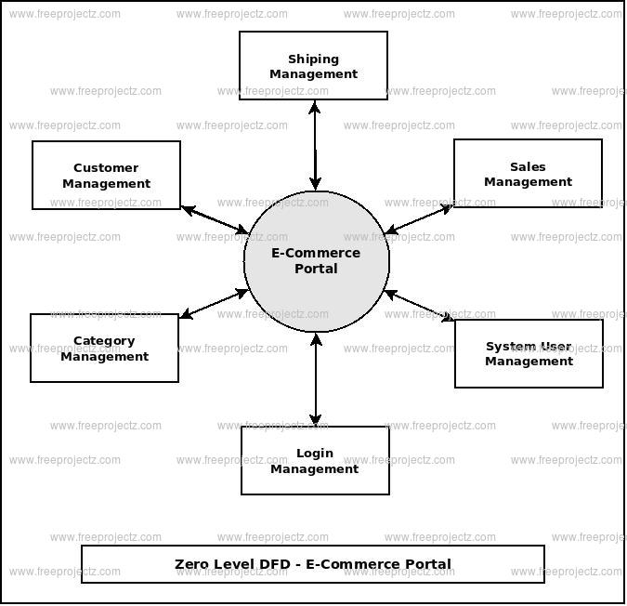

* 1. LEVEL – ONE DFD

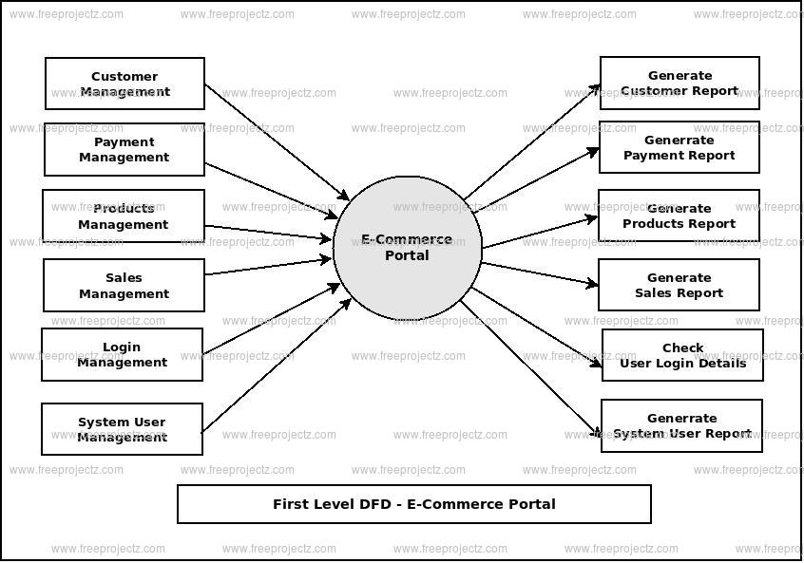

* 1. LEVEL – TWO DFD

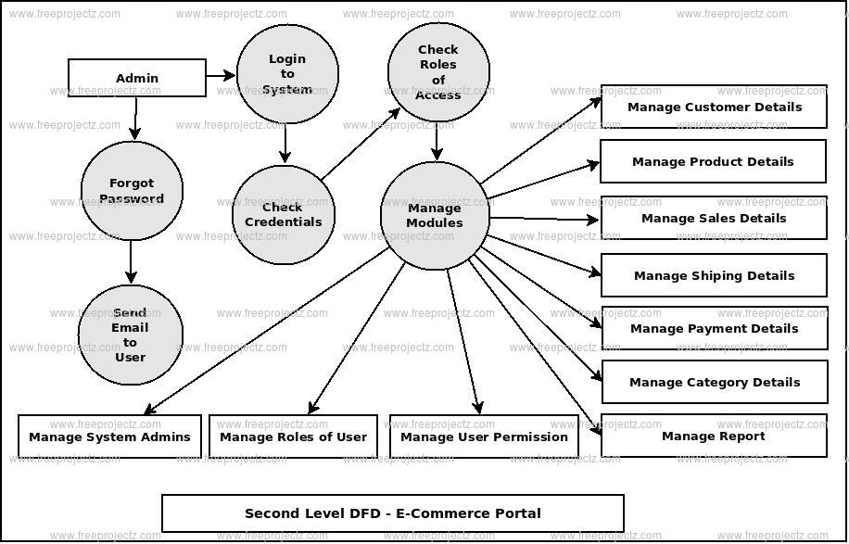

1. **CLIENT APPROVAL PROOF**

Project Name: E-commerce Website

Client: Shresth Sharma

Date: 2024-04-10

We,Sharma clothings, hereby acknowledge that we have reviewed and approved the specifications, functionalities, and requirements outlined in the E-commerce Website project proposal. We understand and accept the proposed design, features, and constraints described therein.

This approval signifies our agreement to proceed with the development and implementation of the E-commerce Website as outlined in the project proposal. We confirm our commitment to providing any necessary resources, information, and assistance required for the successful completion of the project.

We understand that any changes or deviations from the agreed-upon specifications may require reevaluation and approval from both parties. Furthermore, we acknowledge that the timelines, budget, and scope of the project may be subject to adjustment based on unforeseen circumstances or changes in requirements.

Client's Signature:

Date: 2024-04-04

Date: 2024-04-05

1. **CONCLUSION**

In conclusion, our E-commerce Website project marks a significant step forward in meeting the dynamic needs of today’s digital shoppers. We have meticulously crafted and implemented a robust platform that addresses the diverse demands of online shopping, using user-friendly design and strategic planning.

Throughout this project, we have provided a comprehensive overview of its context and relevance, affirming its alignment with contemporary trends and research in e-commerce. Our clearly articulated aims and objectives reflect our dedication to creating an intuitive, efficient, and secure environment for online transactions.

By detailing the purpose, scope, and applicability of our E-commerce Website, we have illustrated its capacity to simplify the shopping process and improve customer satisfaction. We identified and tackled specific challenges in the e-commerce domain, laying the groundwork for a solution that supports both consumers and merchants effectively.

With precise requirement specifications, we have delineated the various features and functionalities of our platform, including advanced search options, streamlined checkout processes, and efficient account management. By thoroughly understanding the problem domain, we have developed a comprehensive system model that integrates all critical operations and procedures.

Additionally, we have placed a high priority on user interface design and security measures, ensuring robust data protection, secure payment processing, and reliable user authentication. Our platform is designed to deliver a seamless and engaging experience for users, bolstering their confidence and trust in our e-commerce system.

Looking forward, we are committed to continuously enhancing our E-commerce Website. This includes the potential introduction of innovative features, enhancements to the user interface, and the integration of cutting-edge technologies. Through ongoing maintenance, upgrades, and valuable user feedback, we are confident that our platform will keep evolving and stand out as a key resource for online shoppers.

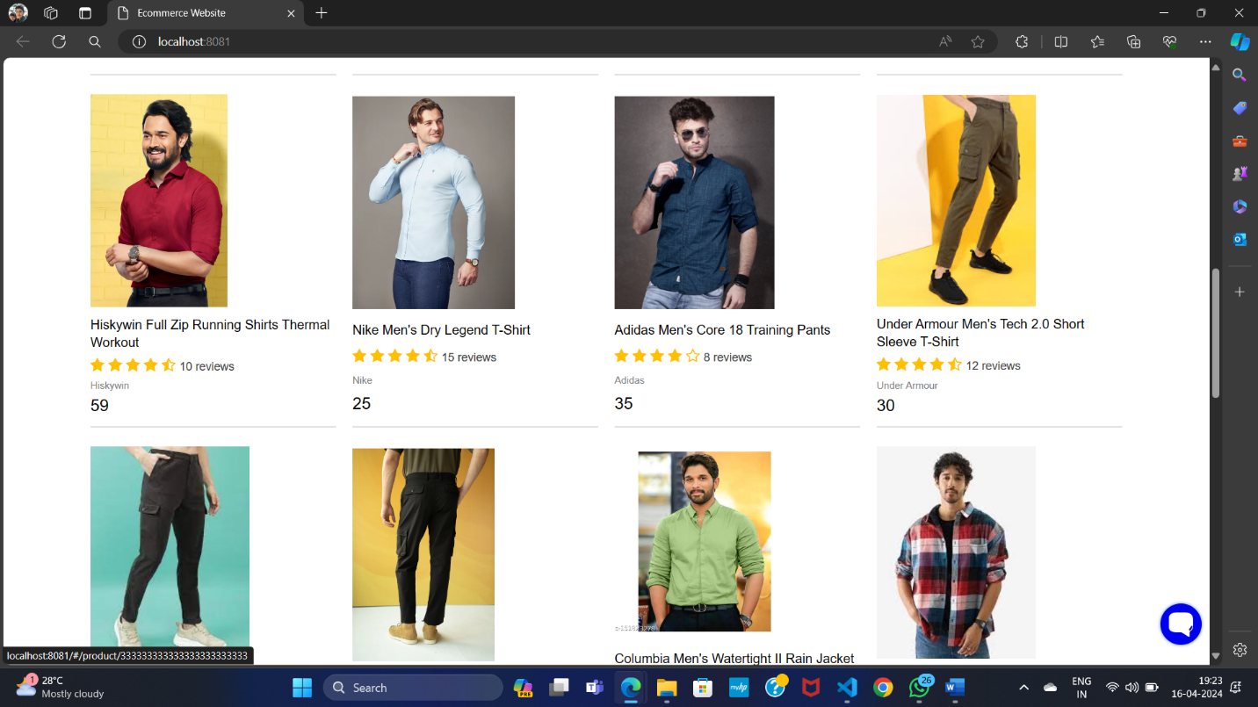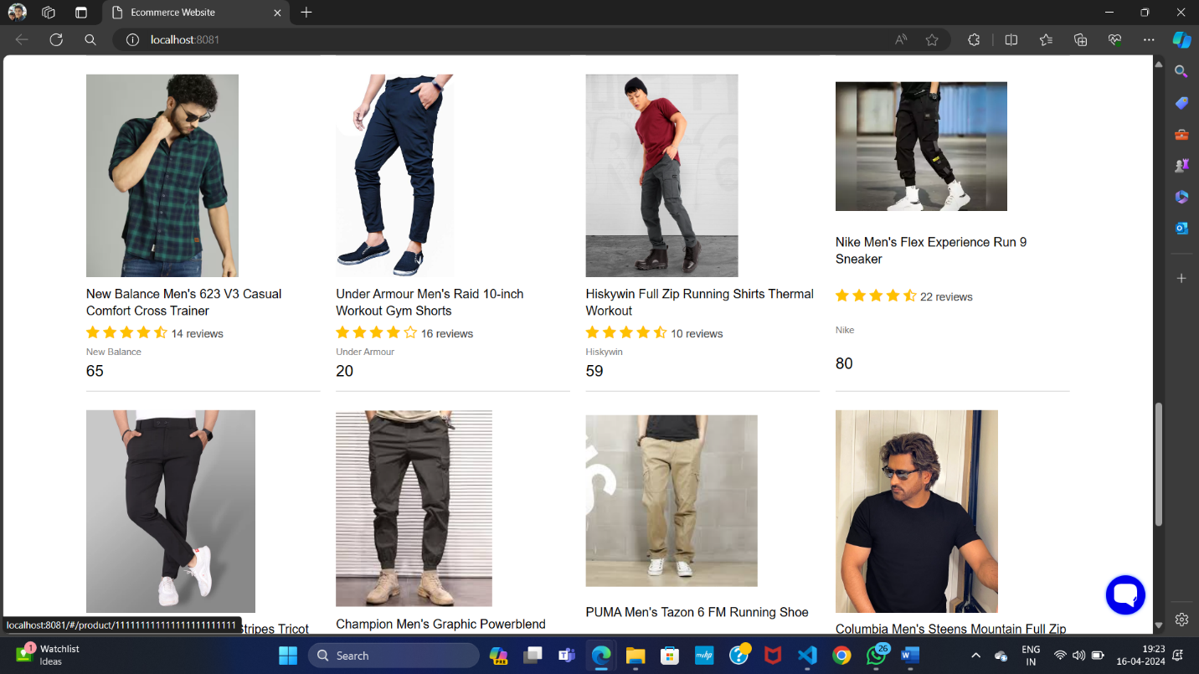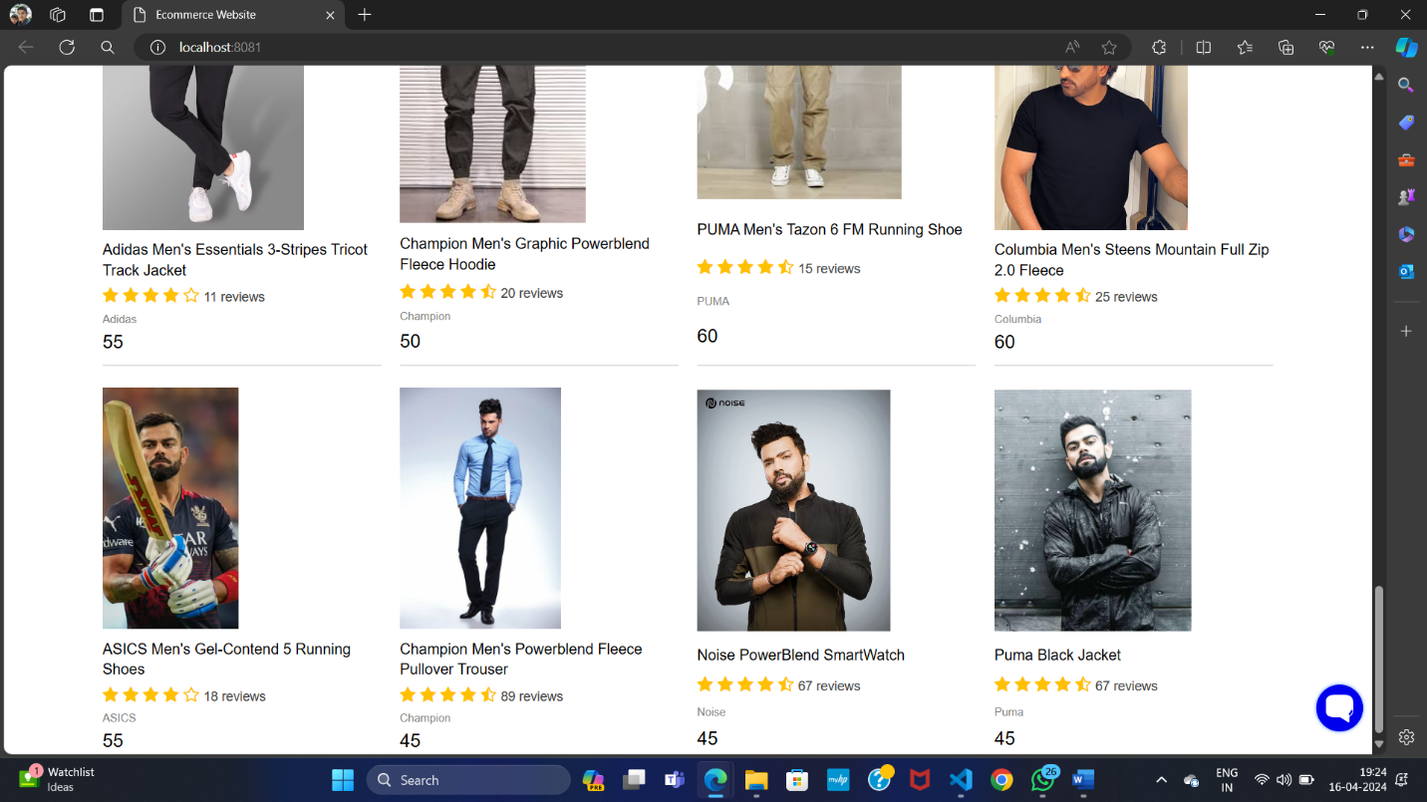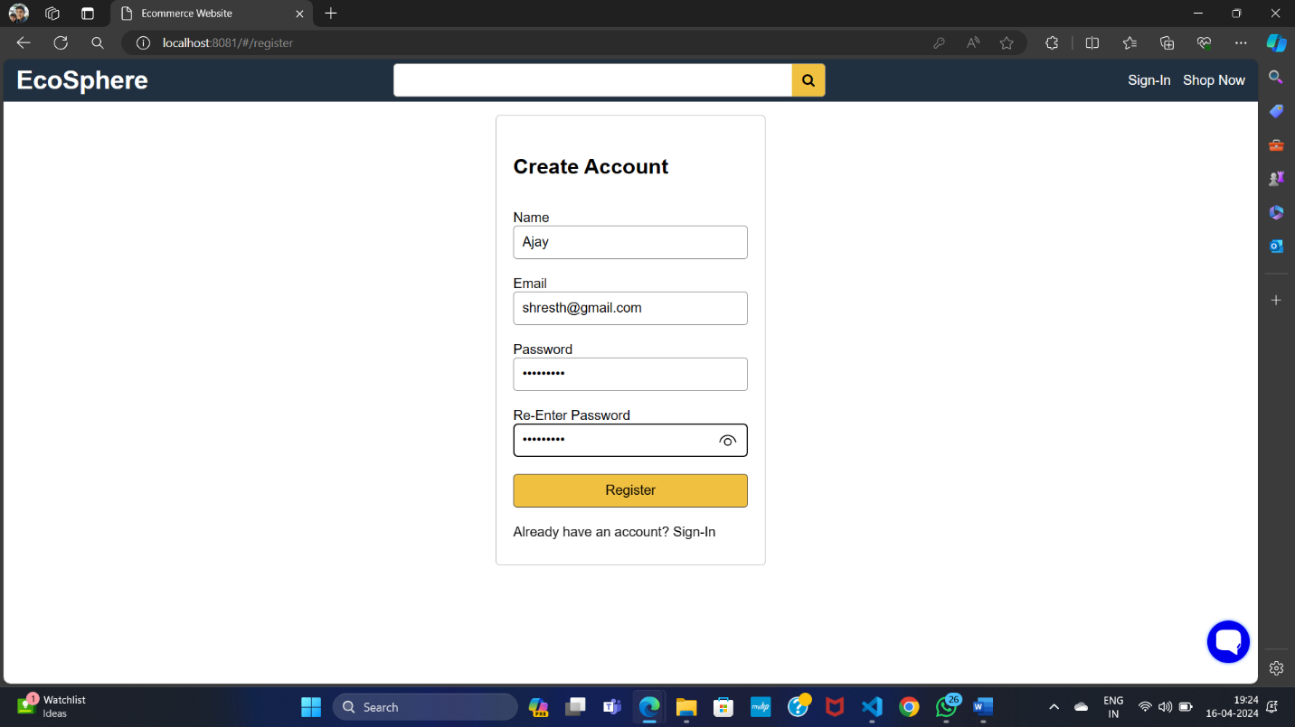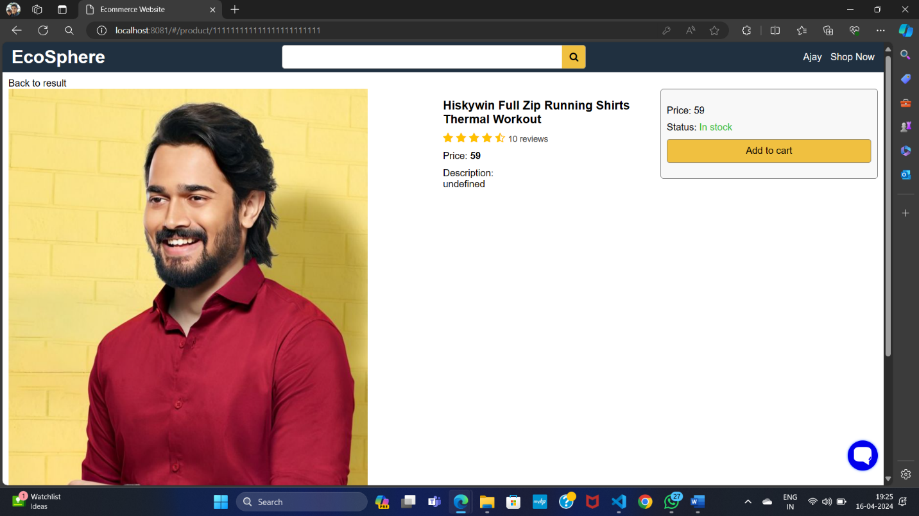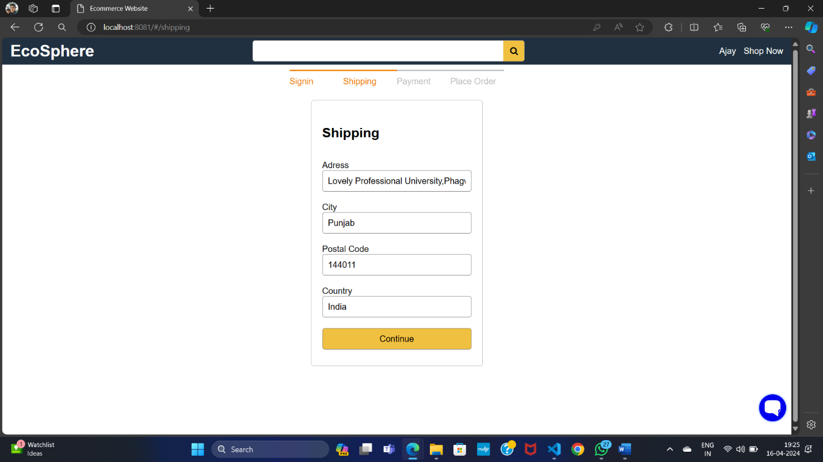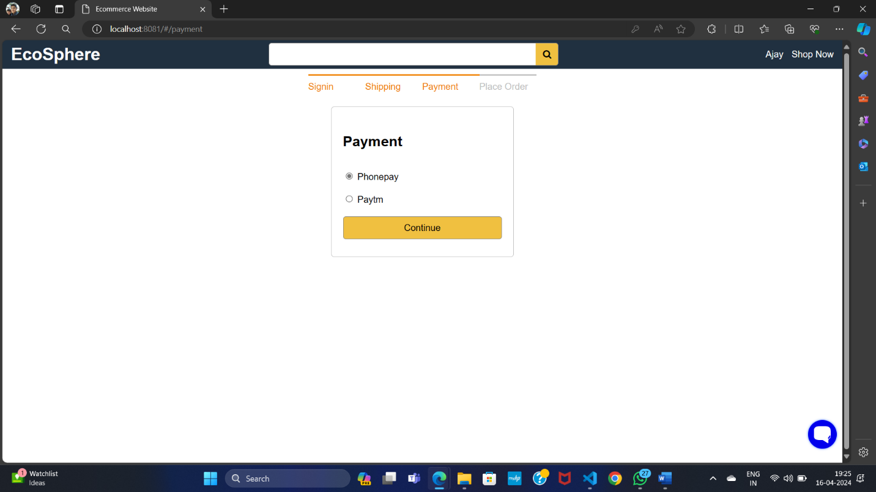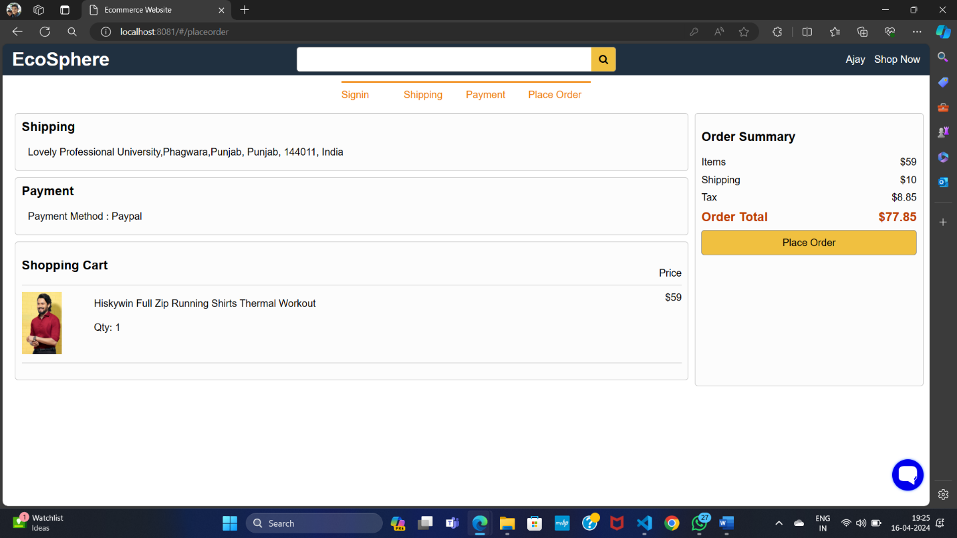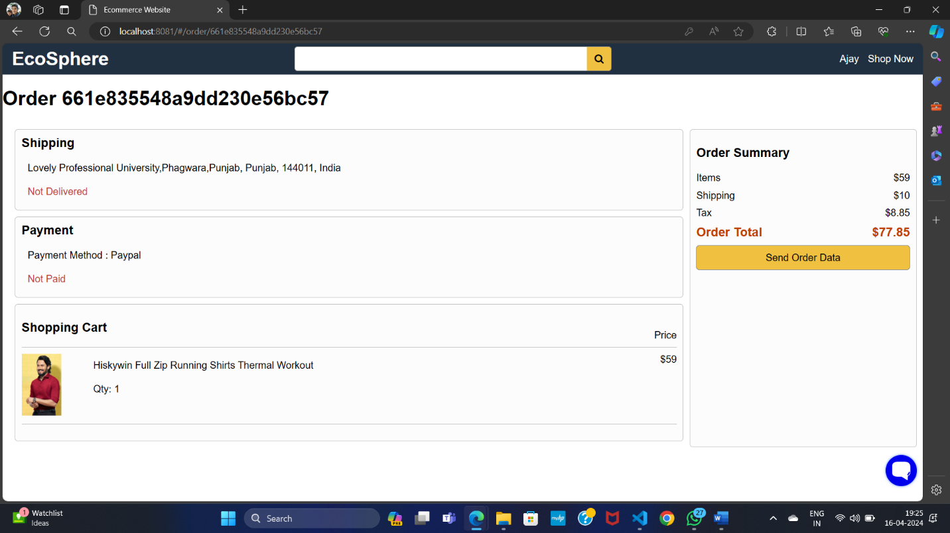

***Thanks!!***